Dear Black Opportunity Fund supporter,
You are invited to a virtual Townhall on Thursday, June 29th, from 6:30 p.m. EST – 8:00 p.m. EST to commemorate Black Opportunity Fund’s 3rd Anniversary. Join us as we reflect on our accomplishments to date and discuss the work still ahead.
We look forward to your attendance at this meeting, where you are encouraged to ask questions, give feedback on our initiatives, our priorities, and the progress we're making in fulfilling our mandate to serve and empower Canada's diverse Black communities.
From day one we have demonstrated our commitment to transparency and meaningful community engagement. That's why this townhall is important. We hope to see you there!
More details, including the agenda, to come later.
Simultaneous French/English translation will be available.
Please register by clicking the button at the bottom of this message.
_______________________________________________________
Support our mission by donating to Black Opportunity Fund
ENG: https://www.canadahelps.org/en/dn/72237/
_______________________________________________________________

Please note this is a secure call, only those who have registered and received the link will be permitted onto the call. Please ensure the email address or your name match your registration for entry.

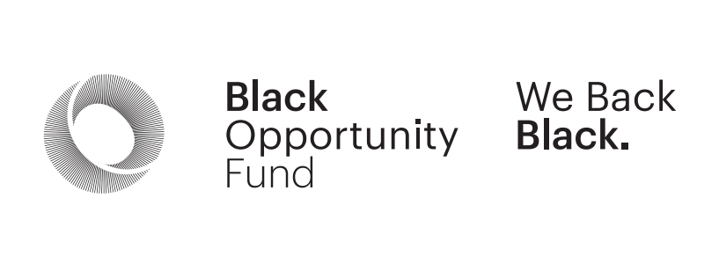
BOF 3rd ANNIVERSARY AGENDA
June 29th, 2023
6:30 p.m. – 8:00 p.m. EST
- Welcome and Intro
Indigenous Land and African Ancestral Acknowledgement (Donna Walwyn)
- Greetings from BOF Board Chair – Ray Williams
- Executive Director Introduction (Craig Wellington)
- Grant Program Recipients Video Highlights
- Partner Message from TD (Alicia Rose)
- BOF Criminal Justice and Arts & Culture Grants Program (Donna Walwyn & Muzunza Musumbulwa) - Funded by TD Ready Commitment & Ontario Law Foundation
- BOF Black Business Loan Program (Craig Wellington & Dr. C. Justine Pierre)
- Wrap-Around Supports for Black Entrepreneurs (Craig Wellington (BOF) & Doug Minter (CBCC) - Funded by CIBC Foundation and BMO
- Wrap-Around Supports for B3s (Nicole Salmon & Nneka Allen (Black Canadian Fundraisers Collective) - Funded by RBC Foundation
- BFN (Black Founders Network) Acceleate 2023 (Efosa Ebona ED and Olu Olubanjo, Founder, Reeddi)
- Black Life Education & Community Engagement Initiative (Leslie Norville)
- Sick Kids BOF Sickle Cell Partnership (Ato Sekyi-Otu and Bukola Salami introducing Dr. Isaac Odeme)
- Greeting from Madame Michaëlle Jean - Michaëlle Jean Foundation video
- BOF Venture (Dennis Mitchell, Lekan Olawoye, Craig Wellington)
- Q & A

